**CIA - 2**

**727721EUIT130**

Question - 1

package com.test.test;

import org.openqa.selenium.By;

import org.openqa.selenium.WebDriver;

import org.openqa.selenium.chrome.ChromeDriver;

import org.openqa.selenium.chrome.ChromeOptions;

import org.testng.annotations.Test;

import io.github.bonigarcia.wdm.WebDriverManager;

public class ca2_1 {

*@Test*

public void f() throws InterruptedException{

ChromeOptions co=new ChromeOptions();

co.addArguments("--remote-allow-origins=*");

WebDriverManager.*chromedriver*().setup();

WebDriver driver=new ChromeDriver(co);

driver.get("https://www.trivago.in/");

driver.manage().window().maximize();

String currtitle=driver.getTitle();

System.***out***.println(currtitle);

String exptitle="trivago.in - Compare hotel prices worldwide";

if(currtitle.equals(exptitle)) {

System.***out***.println("Title get Matched");

}

else {

System.***out***.println("Title not get Matched");

}

Thread.*sleep*(3000);

driver.findElement(By.*xpath*("//*[@id=\"input-auto-complete\"]")).click();

Thread.*sleep*(3000);

driver.findElement(By.*xpath*("//*[@id=\"suggestion-list\"]/ul/li[1]/div/div")).click();

Thread.*sleep*(3000);

driver.findElement(By.*xpath*("//*[@id=\"__next\"]/div[1]/div[1]/section/div[2]/div[3]/div/div[2]/div/div/div/div[2]/div/div[1]/div[2]/button[24]/time")).click();

Thread.*sleep*(3000);

driver.findElement(By.*xpath*("//*[@id=\"__next\"]/div[1]/div[1]/section/div[2]/div[3]/div/div[2]/div/div/div/div[2]/div/div[1]/div[2]/button[26]/time")).click();

Thread.*sleep*(3000);

driver.findElement(By.*xpath*("//*[@id=\"__next\"]/div[1]/div[1]/section/div[2]/div[3]/div/div[2]/div/div/div[1]/div/div[1]/div[1]/div/button[2]")).click();

Thread.*sleep*(3000);

driver.findElement(By.*xpath*("//*[@id=\"__next\"]/div[1]/div[1]/section/div[2]/div[3]/div/div[2]/div/div/div[1]/div/div[1]/div[3]/div/button[2]")).click();

Thread.*sleep*(3000);

driver.findElement(By.*xpath*("/html/body/div[1]/div[1]/div[1]/section/div[2]/div[3]/div/div[2]/div/div/div[1]/div/div[2]/div[2]/input")).click();

Thread.*sleep*(3000);

driver.findElement(By.*xpath*("//*[@id=\"__next\"]/div[1]/div[1]/section/div[2]/div[3]/div/div[2]/div/div/div[2]/div/button[2]")).click();

}

}

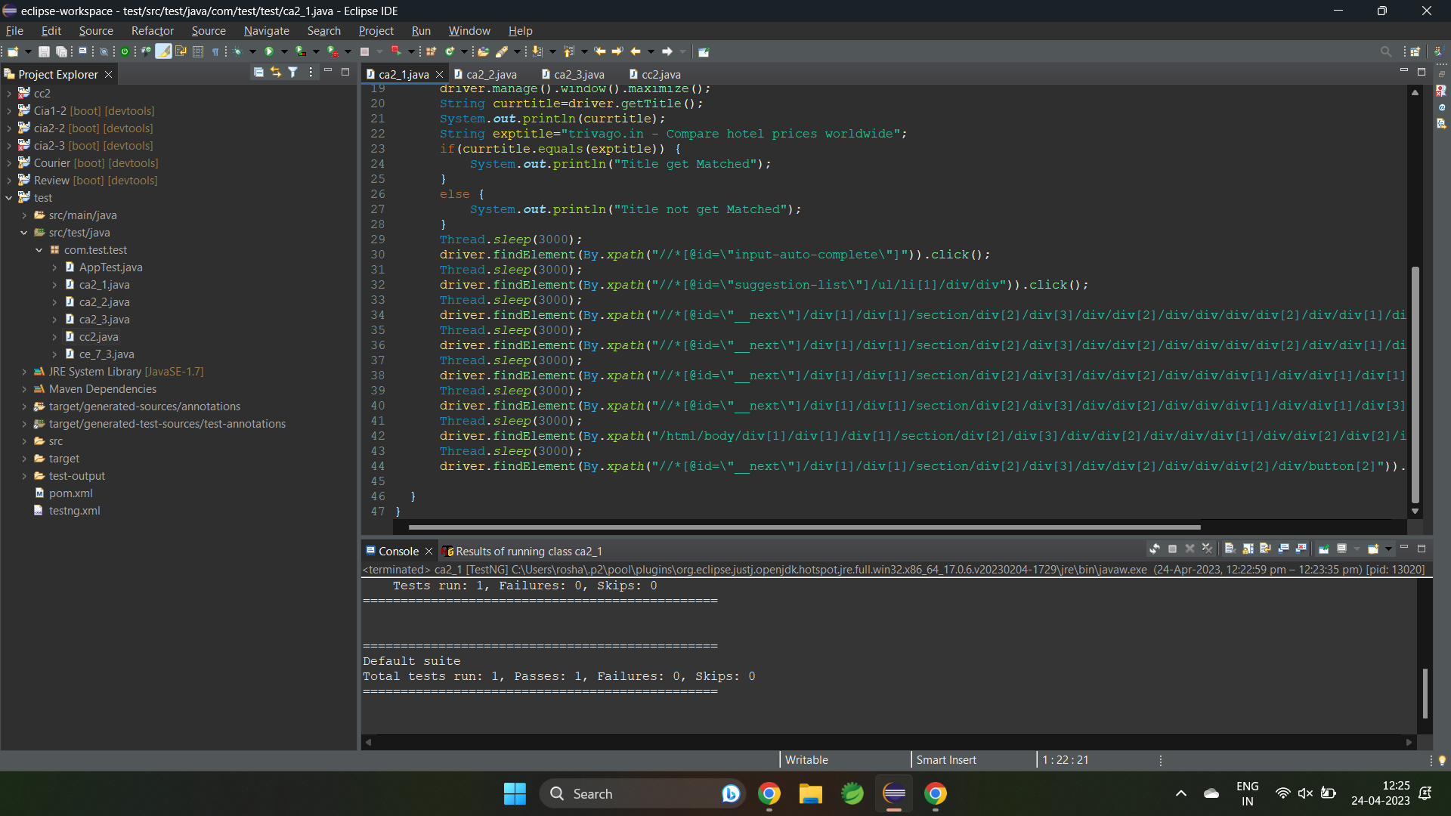

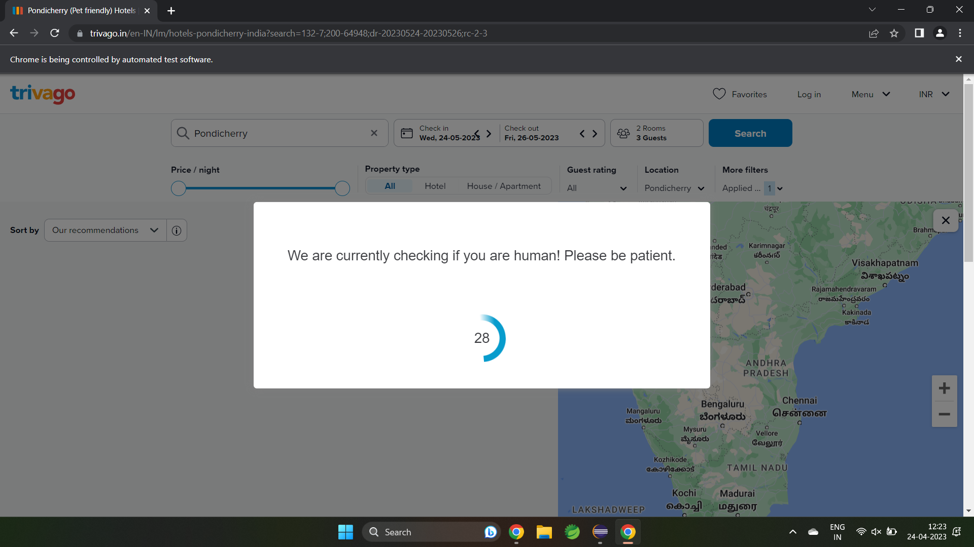

Question - 2

package com.test.test;

import org.openqa.selenium.By;

import org.openqa.selenium.WebDriver;

import org.openqa.selenium.WebElement;

import org.openqa.selenium.chrome.ChromeDriver;

import org.openqa.selenium.chrome.ChromeOptions;

import org.testng.annotations.Test;

import io.github.bonigarcia.wdm.WebDriverManager;

public class ca2_2 {

WebDriver driver;

*@Test*

public void f() throws InterruptedException{

ChromeOptions co=new ChromeOptions();

co.addArguments("--remote-allow-origins=*");

WebDriverManager.*chromedriver*().setup();

WebDriver driver=new ChromeDriver(co);

driver.get("https://www.trivago.in/");

driver.manage().window().maximize();

String currtitle=driver.getTitle();

System.***out***.println(currtitle);

driver.findElement(By.*xpath*("//*[@id=\"input-auto-complete\"]")).click();

Thread.*sleep*(3000);

driver.findElement(By.*xpath*("//*[@id=\"suggestion-list\"]/ul/li[1]/div/div")).click();

Thread.*sleep*(3000);

driver.findElement(By.*xpath*("//*[@id=\"__next\"]/div[1]/div[1]/section/div[2]/div[3]/div/div[2]/div/div/div/div[2]/div/div[1]/div[2]/button[24]/time")).click();

Thread.*sleep*(3000);

driver.findElement(By.*xpath*("//*[@id=\"__next\"]/div[1]/div[1]/section/div[2]/div[3]/div/div[2]/div/div/div/div[2]/div/div[1]/div[2]/button[26]/time")).click();

Thread.*sleep*(3000);

driver.findElement(By.*xpath*("//*[@id=\"__next\"]/div[1]/div[1]/section/div[2]/div[3]/div/div[2]/div/div/div[1]/div/div[1]/div[1]/div/button[2]")).click();

Thread.*sleep*(3000);

driver.findElement(By.*xpath*("//*[@id=\"__next\"]/div[1]/div[1]/section/div[2]/div[3]/div/div[2]/div/div/div[1]/div/div[1]/div[3]/div/button[2]")).click();

Thread.*sleep*(3000);

driver.findElement(By.*xpath*("/html/body/div[1]/div[1]/div[1]/section/div[2]/div[3]/div/div[2]/div/div/div[1]/div/div[2]/div[2]/input")).click();

Thread.*sleep*(3000);

driver.findElement(By.*xpath*("//*[@id=\"__next\"]/div[1]/div[1]/section/div[2]/div[3]/div/div[2]/div/div/div[2]/div/button[2]")).click();

Thread.*sleep*(40000);

driver.findElement(By.*xpath*("//*[@id=\"sorting-selector\"]")).click();

driver.findElement(By.*xpath*("//*[@id=\"sorting-selector\"]/option[4]")).click();

Thread.*sleep*(3000);

WebElement name=driver.findElement(By.*xpath*("//*[@id=\"__next\"]/div[1]/main/div[5]/section/div/div/ol/li[1]/div/article/div[2]/div[1]/section/h2/button/span"));

WebElement price=driver.findElement(By.*xpath*("//*[@id=\"__next\"]/div[1]/main/div[5]/section/div/div/ol/li[1]/div/article/div[2]/div[1]/section/h2/button/span"));

WebElement stays=driver.findElement(By.*xpath*("//*[@id=\"__next\"]/div[1]/main/div[5]/div[3]/div/div[2]/div[1]/div/div[2]/div[2]/div/div/div[1]/span[2]/strong"));

WebElement sites=driver.findElement(By.*xpath*("//*[@id=\"__next\"]/div[1]/main/div[5]/div[3]/div/div[2]/div[1]/div/div[2]/div[2]/div/div/div[2]/span[2]/strong"));

System.***out***.print("Hotel Name : "+name.getText());

System.***out***.print("Hotel Price : "+price.getText());

System.***out***.print("Stays Found : "+stays.getText());

System.***out***.print("Number of Booking sites Searched : "+sites.getText());

}

}

Question - 3

package com.test.test;

import java.util.List;

import org.openqa.selenium.By;

import org.openqa.selenium.WebDriver;

import org.openqa.selenium.WebElement;

import org.openqa.selenium.chrome.ChromeDriver;

import org.openqa.selenium.chrome.ChromeOptions;

import org.testng.annotations.Test;

import io.github.bonigarcia.wdm.WebDriverManager;

*@Test*

public class ca2_3 {

WebDriver driver;

public void TC_003() {

WebDriverManager.*chromedriver*().setup();

ChromeOptions co=new ChromeOptions();

co.addArguments("--remote-allow-origins=*");

driver=new ChromeDriver(co);

driver.get("https://www.trivago.in/");

driver.manage().window().maximize();

String txt1=driver.findElement(By.*xpath*("//*[@id=\"search\"]/div[1]/div[1]/div/span[1]/div[1]/div[3]/div/div/div/div/div/div/div/div[2]/div/div/div[1]/h2/a/span")).getText();

System.***out***.println(txt1);

String txt2=driver.findElement(By.*xpath*("//*[@id=\"search\"]/div[1]/div[1]/div/span[1]/div[1]/div[4]/div/div/div/div/div/div/div/div[2]/div/div/div[1]/h2/a/span")).getText();

System.***out***.println(txt2);

String txt3=driver.findElement(By.*xpath*("//*[@id=\"search\"]/div[1]/div[1]/div/span[1]/div[1]/div[5]/div/div/div/div/div/div[2]/div/div/div[1]/h2/a/span")).getText();

System.***out***.println(txt3);

String txt4=driver.findElement(By.*xpath*("//*[@id=\"search\"]/div[1]/div[1]/div/span[1]/div[1]/div[6]/div/div/div/div/div/div[2]/div/div/div[1]/h2/a/span")).getText();

System.***out***.println(txt4);

String txt5=driver.findElement(By.*xpath*("//*[@id=\"search\"]/div[1]/div[1]/div/span[1]/div[1]/div[7]/div/div/div/div/div/div[2]/div/div/div[1]/h2/a/span")).getText();

System.***out***.println(txt5);

driver.findElement(By.*xpath*("//*[@id=\"sorting-selector\"]/option[3]")).click();

String currentprice=driver.findElement(By.*xpath*("//*[@id=\"__next\"]/div/div[1]/main/div[3]/div[1]/div/div[3]/div/div/ol/li/div/article/div[2]/div[2]/div[1]/div/div[3]/div[1]/div/p")).getText();

String expectedprice="trivago.in - Compare hotel prices worldwide";

System.***out***.println(currentprice);

if(currentprice.equals(expectedprice)) {

System.***out***.println("price Matched");

}

else {

System.***out***.println("price not Matched");

}

driver.findElement(By.*xpath*("//*[@id=\"__next\"]/div/div[1]/main/div[3]/div[1]/div/div[3]/div/div/ol/li/div/article/div[2]/div[2]/div[1]/div/div[3]/div[2]/button/span/span[1]")).click();

driver.findElement(By.*xpath*("//*[@id=\"contentContainer\"]/div[3]/ol/li[1]/div[2]/a/div/div[2]/div")).click();

driver.findElement(By.*xpath*("//*[@id=\"hotelNavBar\"]/div/ul/li[2]/button/span")).click();

driver.findElement(By.*xpath*("//*[@id=\"ChildRoom-Ch8I2vnABhACIA4ojuUhMARAAUoJN0QxTl8xMDBQUJgFEgIIARoGEAIoBDAB\"]/div/div[4]/div[2]/div/div[1]/button/div")).click();

WebElement txtBoxl=driver.findElement(By.*xpath*("//*[@id=\"Fullname\"]"));

txtBoxl.sendKeys("Roshan");

}

}

